Computer Architecture Lab
(EL-2012)
LABORATORY REPORT

Fall 2026

(Lab#10)
Implementation of Data Path

Student Name: _______Syed Sikandar Abbas___ Roll No: __i246553___ Section: CE-B

Date performed: _____October 26, 2026

MARKS AWARDED: ________ / 10

Signature and date of Instructor: _________________
Lab Instructors: Dr. Nasir Ali Shah, Engr. Fasih Ahmad

______________________________________________________________________________________________________________________________________________________

NATIONAL UNIVERSITY OF COMPUTER AND EMERGING SCIENCES, ISLAMABAD
Prepared by: | Fasih Ahmad |  | Version: 1.0
Verified by: | Dr. Nasir Ali Shah |  | Updated: Fall 2026

Task 1:

Description:
Designed and simulated a data-path for the processor that has been implemented for the project. Followed the design given in the figure 1 w.r.t RV32 (given in table 6) of the Lab Manual.
Code:
module program_counter (
output reg [3:0] address,
input pc_inc,
input clk,
input clr
);
always @(posedge clk or posedge clr) begin
if (clr)
address <= 4'b0000;
else if (pc_inc)
address <= address + 1;
end
endmodule

module alu_4bit (
input [3:0] A, B,
input [2:0] alu_control,
output reg [3:0] result
);
always @(*) begin
case (alu_control)
3'b000: result = A & B; // AND
3'b001: result = A | B; // OR
3'b010: result = A + B; // ADD
3'b110: result = A - B; // SUB
3'b111: result = (A < B) ? 4'b0001 : 4'b0000; // SLT
default: result = 4'b0000;
endcase
end
endmodule

module decoder_2_to4 (output reg [3:0] dec_out, input [1:0] wr, input write_enable);
always @(*) begin
if (write_enable) begin
case (wr)
2'b00: dec_out = 4'b0001;
2'b01: dec_out = 4'b0010;
2'b10: dec_out = 4'b0100;
2'b11: dec_out = 4'b1000;
default: dec_out = 4'b0000;
endcase
end else begin
dec_out = 4'b0000;
end
end
endmodule

module mux4_1 (output reg [3:0] out, input [3:0] in, in1, in2, in3, input [1:0] se1);
always @(*) begin
if (se1 == 2'b00)
out = in;
else if (se1 == 2'b01)
out = in1;
else if (se1 == 2'b10)
out = in2;
else if (se1 == 2'b11)
out = in3;
else
out = 4'b0000; // optional, for safety
end
endmodule

module register_4bit (output reg [3:0] q, input [3:0] d, input load, input clk);
initial begin
q <= 4'b0000;
end
always @(posedge clk) begin
if (load)
q <= d;
end
endmodule

module register_file_4x4 (data_out1, data_out2, data_in, wr, write_enable, rd1, rd2, clk);
// output ports
output [3:0] data_out1;
output [3:0] data_out2;

// input ports
input [3:0] data_in;
input [1:0] wr;
input write_enable;
input [1:0] rd1, rd2;
input clk;

// Internal wires
wire [3:0] dec_out;
wire [3:0] q0, q1, q2, q3;

// Instantiate decoder
decoder_2_to4 decoder (dec_out, wr, write_enable);

// Instantiate four 4-bit registers
register_4bit reg0 (q0, data_in, dec_out [0], clk);
register_4bit reg1 (q1, data_in, dec_out [1], clk);
register_4bit reg2 (q2, data_in, dec_out [2], clk);
register_4bit reg3(q3, data_in, dec_out [3], clk);

// Instantiate two 4-to-1 multiplexers for reading
mux4_1 muxl (data_out1, q0, q1, q2, q3, rd1);
mux4_1 mux2 (data_out2, q0, q1, q2, q3, rd2);
endmodule

module datapath (
input clk,
input clr,
input pc_inc,
input write_enable,
input [3:0] instruction, // [3:2]=Rd, [1:0]=Rs
input [2:0] alu_control, // ALU control signal
input [3:0] ext_data_in, // NEW: External data input
input select_data_source, // NEW: 0=ALU result, 1=external
output [3:0] alu_result,
output [3:0] pc_out
);
wire [1:0] rd = instruction[3:2];
wire [1:0] rs = instruction[1:0];
wire [3:0] read_data1, read_data2;
wire [3:0] data_to_write;
assign data_to_write = (select_data_source) ? ext_data_in : alu_result;

// Program Counter
program_counter PC (
.address(pc_out),
.pc_inc(pc_inc),
.clk(clk),
.clr(clr)
);

// Register File
register_file_4x4 RF (
.data_out1(read_data1),
.data_out2(read_data2),
.data_in(data_to_write), // conditional input
.wr(rd),
.write_enable(write_enable),
.rd1(rs),
.rd2(rs),
.clk(clk)
);

// ALU
alu_4bit ALU (
.A(read_data1),
.B(read_data2),
.alu_control(alu_control),
.result(alu_result)
);
endmodule

module datapath_tb();
reg clk;
reg clr;
reg pc_inc;
reg write_enable;
reg [3:0] instruction;
reg [2:0] alu_control;
reg [3:0] ext_data_in;
reg select_data_source;

wire [3:0] alu_result;
wire [3:0] pc_out;

datapath uut (
.clk(clk),
.clr(clr),
.pc_inc(pc_inc),
.write_enable(write_enable),
.instruction(instruction),
.alu_control(alu_control),
.ext_data_in(ext_data_in),
.select_data_source(select_data_source),
.alu_result(alu_result),
.pc_out(pc_out)
);

always #5 clk = ~clk;

initial begin
clk = 0;
clr = 1;
pc_inc = 0;
write_enable = 0;
instruction = 4'b0000;
alu_control = 3'b000;
ext_data_in = 4'b0000;
select_data_source = 0;

#10;
clr = 0;

#10;
select_data_source = 1;
write_enable = 1;

instruction = 4'b0000;
ext_data_in = 4'b0101;
#10;
instruction = 4'b0100;
ext_data_in = 4'b0011;

#10;
write_enable = 0;
select_data_source = 0;

instruction = 4'b0001;

alu_control = 3'b010;
pc_inc = 1;

#10;
alu_control = 3'b110;

#10;
instruction = 4'b1000;
alu_control = 3'b010;
write_enable = 1;

#10;
write_enable = 0;
pc_inc = 0;

#10;
clr = 1;

#10;
clr = 0;
end
endmodule
Output:
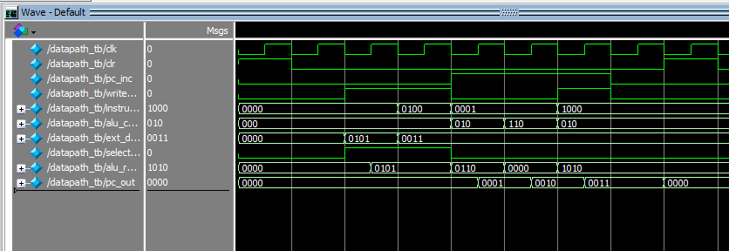

Task 2:

Description:
Logisim of Task 1
Circuit:


